Department of Computer Science and Engineering (Data Science)
CSDS-A | Batch A4 (CSE - Data Science, Section A)
Advanced Optimization in E-Commerce Logistics: Combining Matheuristics With Random Forests for Hub Location Efficiency
(HubOptima)
S.No. | Student name | Roll / hall ticket no.
1 | CH.ARCHANA | 23K91A6745
2 | A.MEENAKSHI | 23K91A6705
3 | B.ARUN | 23K91A6734
4 | A.SAMPATH | 23K91A6712
Under the guidance of: [GUIDE NAME], [DESIGNATION]
BLOCK DIAGRAMS
This document collects every design diagram of HubOptima. Each diagram was drawn from the real code (the hublocator package, the FastAPI layer and the React pages) and is followed by a paragraph that explains it. The diagrams were generated by scripts/make_diagrams.py with matplotlib.
Table 1: Diagrams in this document
No. | Diagram | Shows
1 | System architecture | Layers: browser and command line, React frontend, FastAPI layer, core package, libraries and files
2 | High-level workflow | Ten steps of the predict-then-optimise loop
3 | DFD level 0 | Context: HubOptima and its three external entities
4 | DFD level 1 | Nine processes and four data stores
5 | DFD level 2 | Expansion of the hub-solving process
6 | UML class diagram | Core types, modules and the FastAPI service
7 | Use-case diagram | Actors and their use cases
8 | Sequence diagram | Planning hubs from the browser
9 | ER diagram | File-based data model
10 | Algorithm flowchart | Control flow of the matheuristic

1 System Architecture
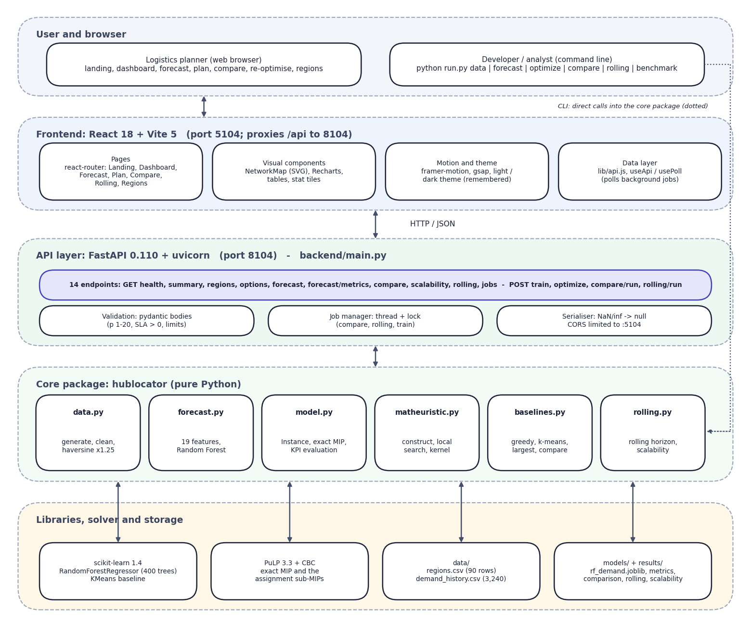
Fig. 1: System architecture of HubOptima
The architecture has five layers. The user works in a browser, or a developer uses the command line. The frontend is a React application served by Vite on port 5104; it holds the seven pages, the SVG network map, the charts, the theme and the small data layer (api.js, useApi, usePoll) that polls background jobs.
The API layer is a FastAPI service on port 8104 with 14 endpoints. It validates request bodies with pydantic, runs long jobs in a thread guarded by a lock, and converts numpy values to JSON (NaN and infinity become null). The core package hublocator contains all of the science: data preparation, the Random Forest, the hub model and exact solver, the matheuristic, the baselines and the rolling-horizon simulation. No forecasting or optimisation logic lives in the API layer.
The bottom layer holds the libraries (scikit-learn, PuLP with CBC) and the files that act as storage: two CSV files in data/, the trained model and metrics in models/ and the result files in results/. The command line calls the core package directly, which is why the dotted line bypasses the web tiers.

2 High-Level Workflow
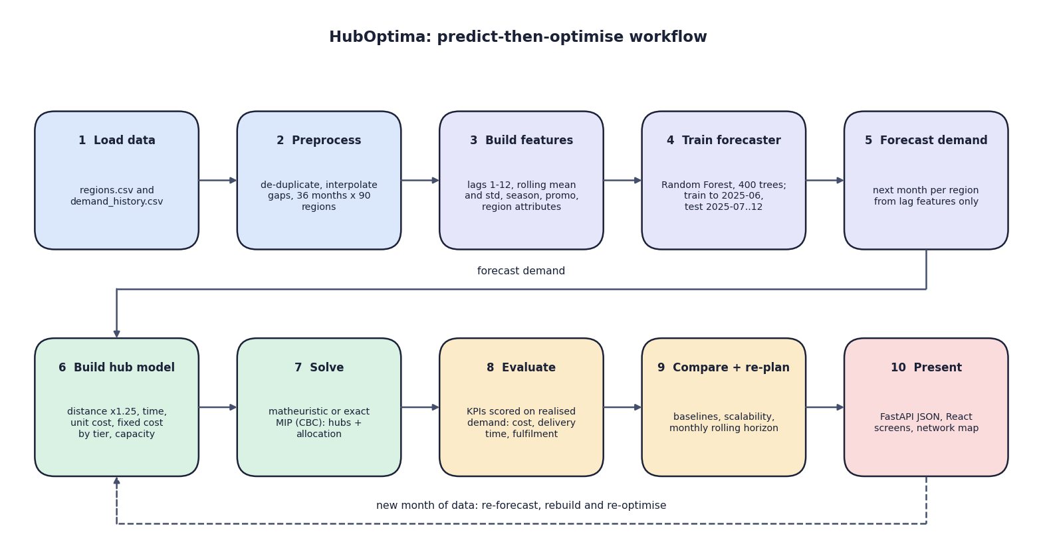
Fig. 2: High-level workflow
The ten steps are the predict-then-optimise loop. Steps 1 to 5 prepare the data and produce a demand forecast; steps 6 and 7 turn the forecast into a hub-location model and solve it; step 8 scores the plan on the demand that actually occurred; step 9 compares methods and re-plans month by month; step 10 presents the outcome. The dashed arrow shows the cycle: when a new month of data arrives the forecast is recomputed, the model is rebuilt and the network is re-optimised.

3 Data-Flow Diagram: Level 0
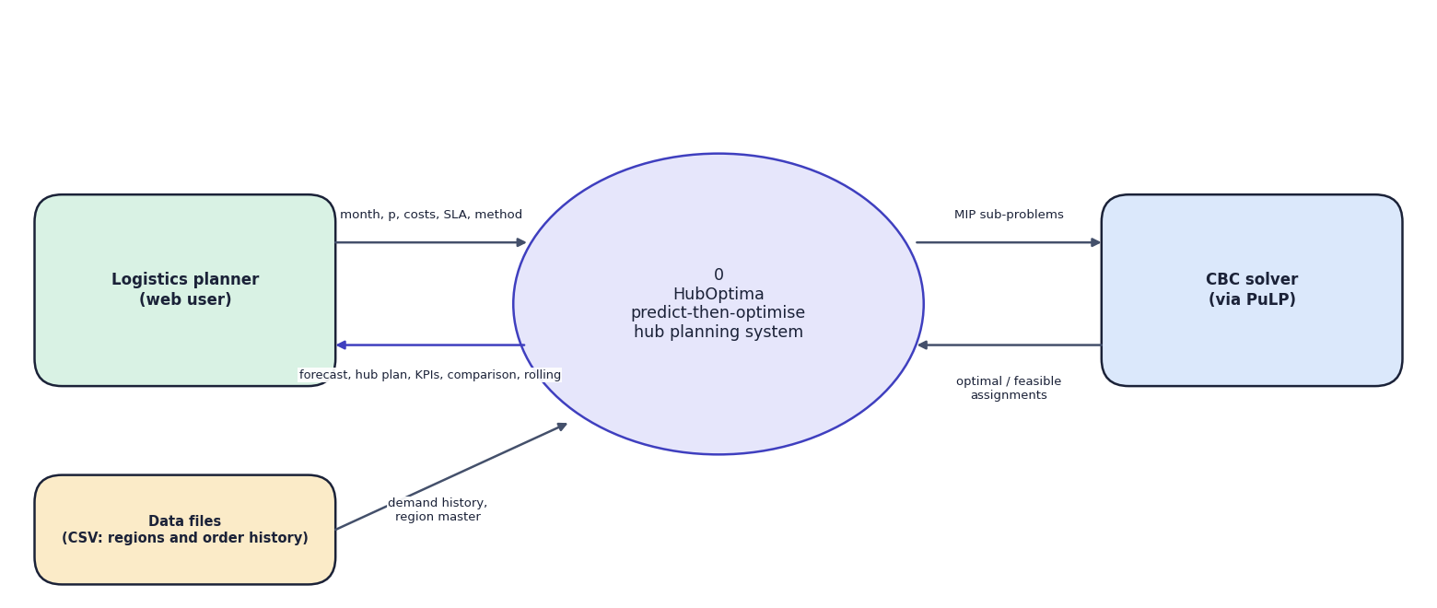
Fig. 3: Data-flow diagram, level 0 (context)
The context diagram shows HubOptima as one process with three external entities. The logistics planner supplies the planning month, the number of hubs, cost and service parameters and the method, and receives forecasts, hub plans, KPIs, comparisons and rolling results. The data files supply the region master and the order history. The CBC solver receives mixed-integer sub-problems and returns optimal or feasible assignments.

4 Data-Flow Diagram: Level 1
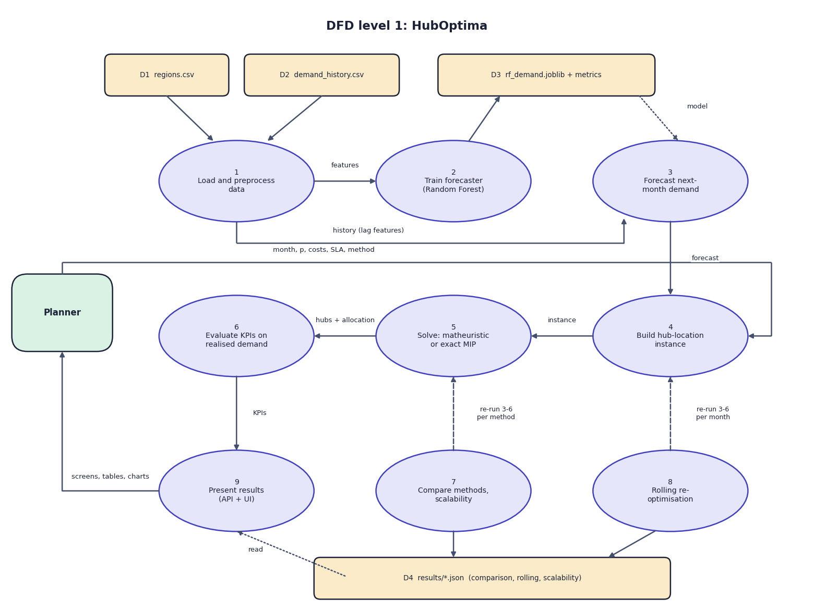
Fig. 4: Data-flow diagram, level 1
Level 1 splits the system into nine processes and four data stores. Process 1 reads regions.csv and demand_history.csv (D1, D2), cleans them and passes features to process 2, which trains the Random Forest and writes the model and its metrics (D3). Process 3 forecasts next month's demand from the model and the history. Process 4 builds the hub-location instance from the forecast and the planner's parameters; process 5 solves it; process 6 evaluates the KPIs on realised demand. Processes 7 (comparison and scalability) and 8 (rolling horizon) re-run processes 3 to 6 for each method or month and store their results in D4. Process 9 presents everything to the planner.

5 Data-Flow Diagram: Level 2
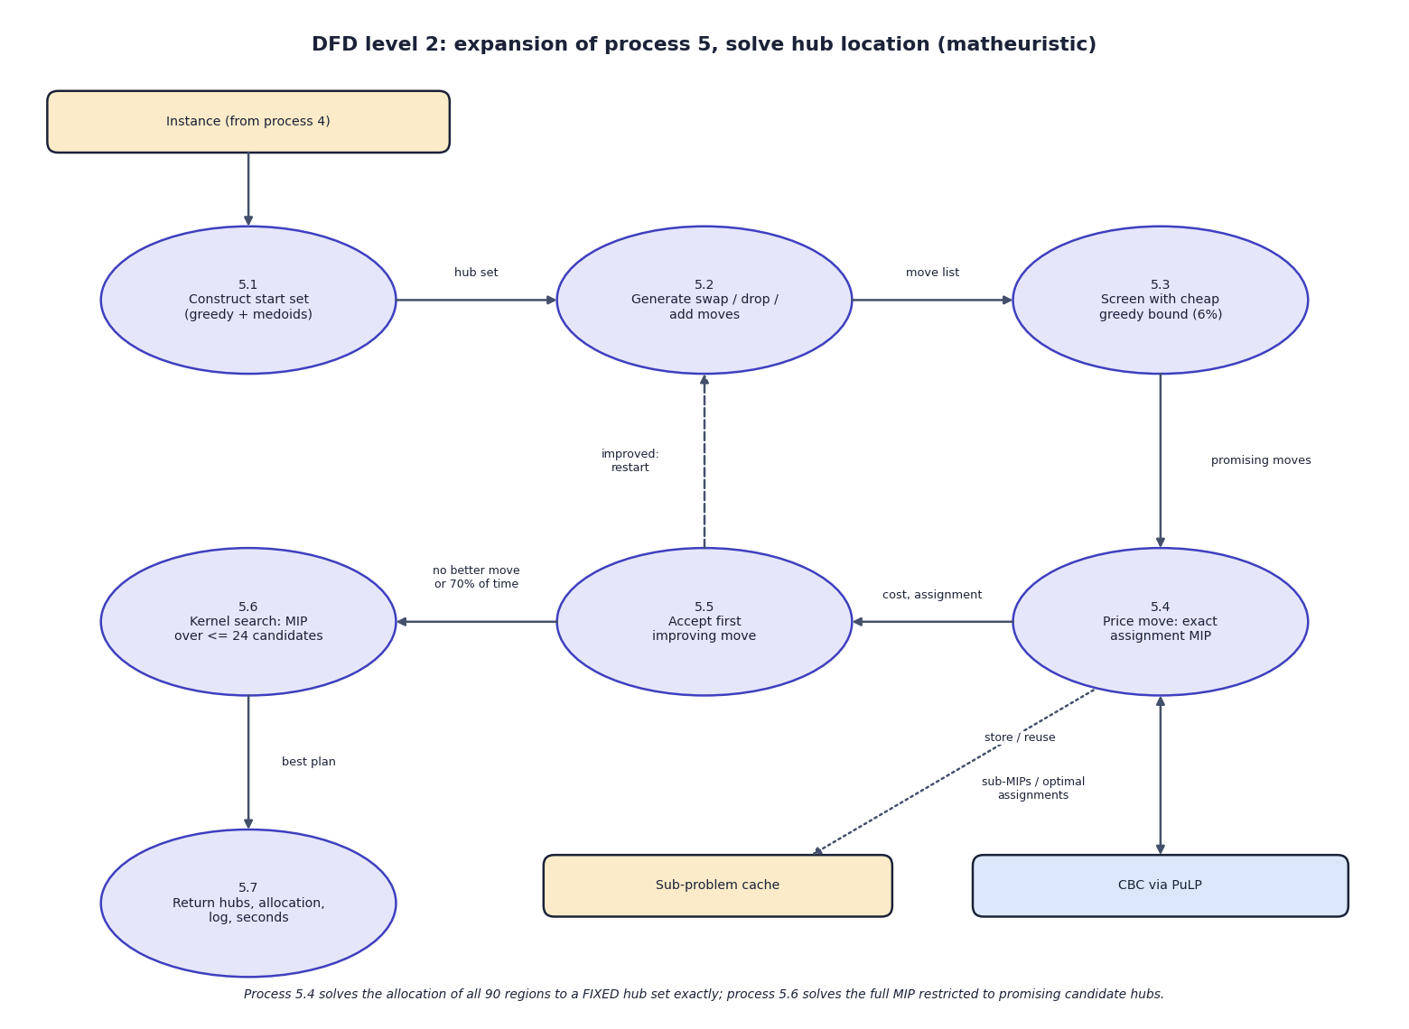
Fig. 5: Data-flow diagram, level 2: solving the hub-location problem
Level 2 opens process 5. The start set is constructed greedily (5.1), moves are generated (5.2) and screened with a cheap greedy cost bound (5.3), the promising ones are priced by an exact assignment MIP solved by CBC (5.4), and the first improving move is accepted (5.5) and triggers a restart. When no move helps, or 70% of the time limit is used, a kernel search solves the full MIP restricted to about 24 promising hubs (5.6) and the best plan is returned (5.7). A cache of priced hub sets avoids solving the same sub-problem twice.

6 UML Class Diagram
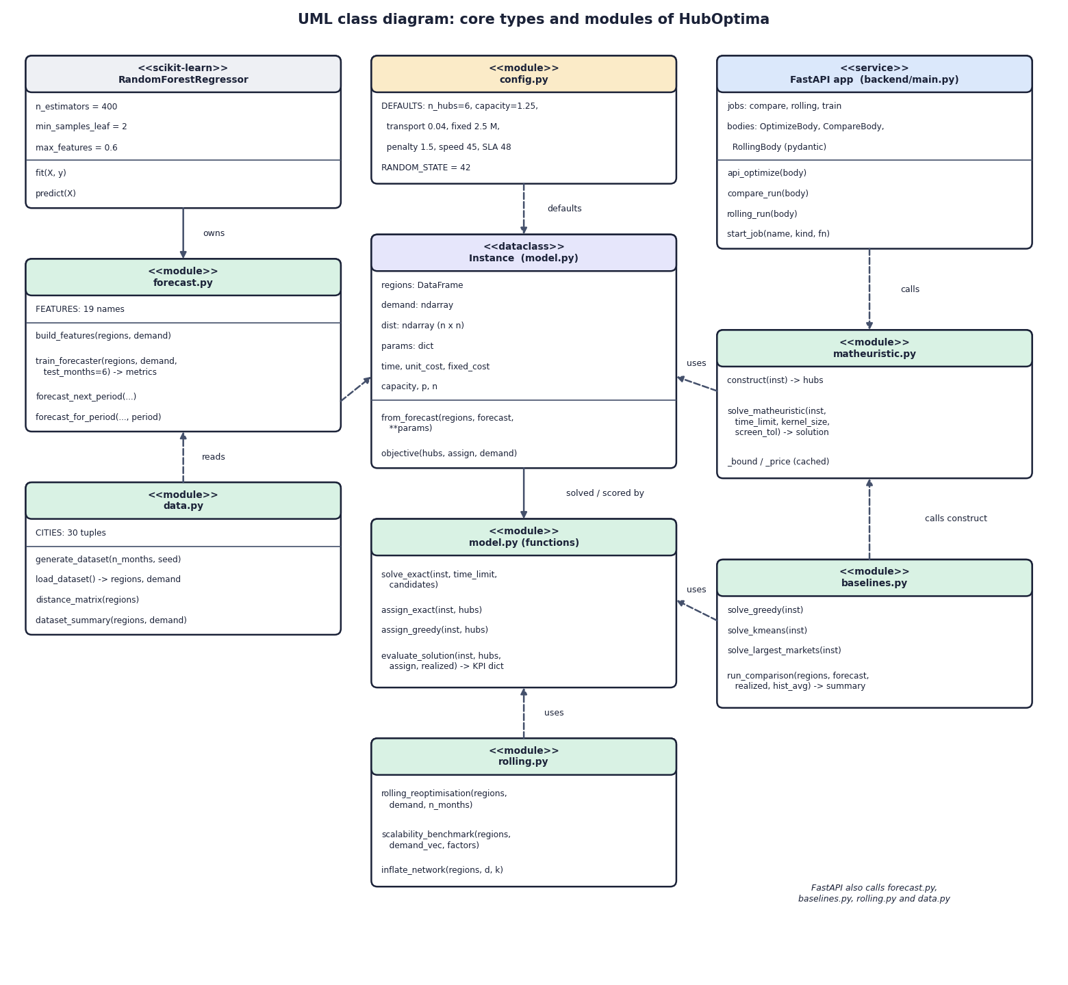
Fig. 6: UML class diagram
The core is the Instance dataclass, which holds the regions, the demand vector, the distance matrix and the parameters and derives the delivery time, the unit cost, the fixed cost per hub and the capacity. The functional modules model.py, matheuristic.py, baselines.py and rolling.py all take an Instance. forecast.py owns the RandomForestRegressor and data.py supplies the data. config.py holds the defaults. The FastAPI application only calls these modules; it defines the three request bodies and the job table.

7 Use-Case Diagram
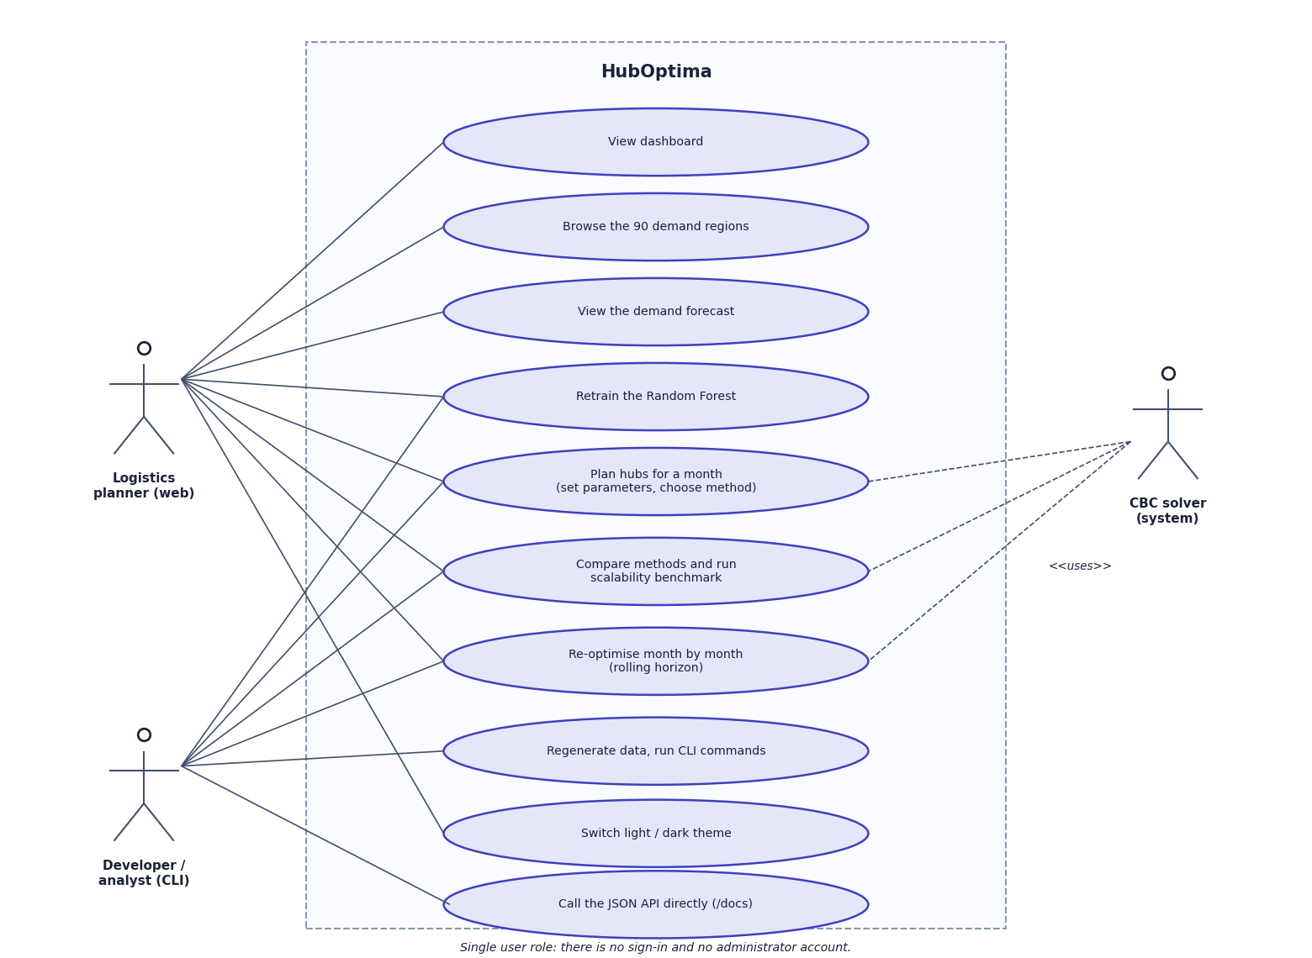
Fig. 7: Use-case diagram
The logistics planner browses the dashboard and regions, views and retrains the forecast, plans hubs, compares methods, runs the scalability benchmark, re-optimises over time and switches the theme. The developer or analyst uses the command line for the same functions and for regenerating the data, and may call the JSON API directly. The CBC solver is a system actor used by planning, comparison and re-optimisation.

8 Sequence Diagram
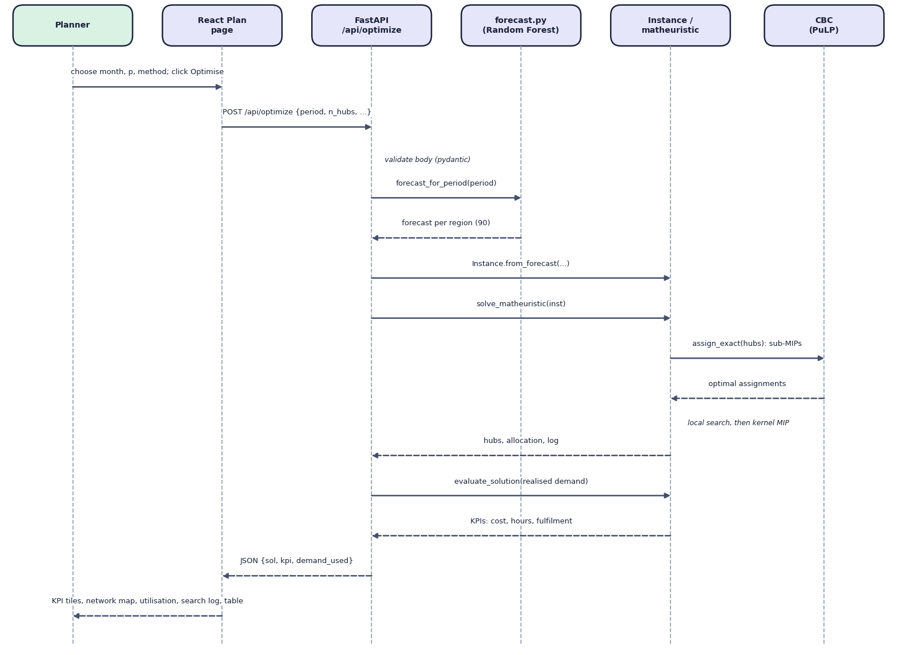
Fig. 8: Sequence diagram of the main flow: planning hubs
The planner chooses a month, the number of hubs and a method and clicks Optimise. The React page posts the body to /api/optimize. FastAPI validates it, obtains the forecast for that month using only earlier data, builds the Instance, and runs the matheuristic, which calls CBC for the assignment sub-problems. The result is scored on the realised demand by evaluate_solution and returned as JSON, which the page turns into KPI tiles, the network map, hub utilisation, the search log and the allocation table.

9 Entity-Relationship Diagram
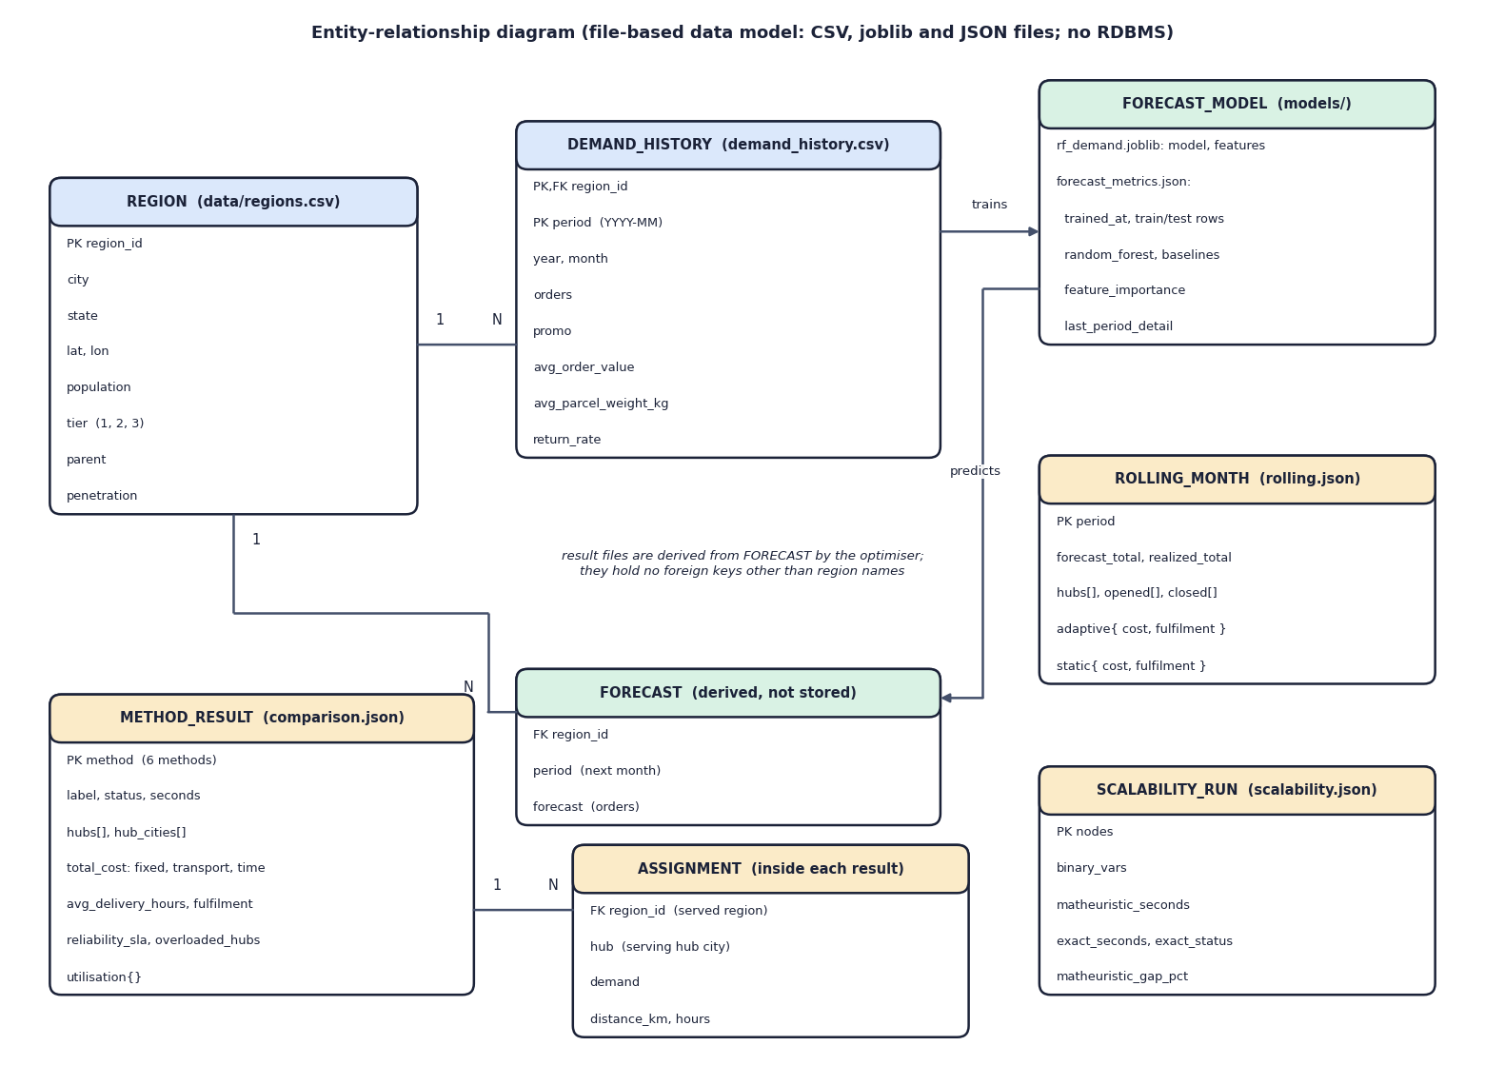
Fig. 9: Entity-relationship diagram of the file-based data model
HubOptima does not use a database. Its data are two CSV files, a joblib model with a JSON metrics file, and JSON result files. The diagram shows them as entities so that the relationships are explicit. A region has many monthly demand-history rows (primary key region and period). The forecast model is trained from the demand history and predicts a forecast per region, which is derived and not stored. The result files (method results with their region-to-hub assignments, rolling-horizon months and scalability runs) are produced by the optimiser from forecasts and hold region names rather than foreign keys.

10 Flowchart of the Core Algorithm
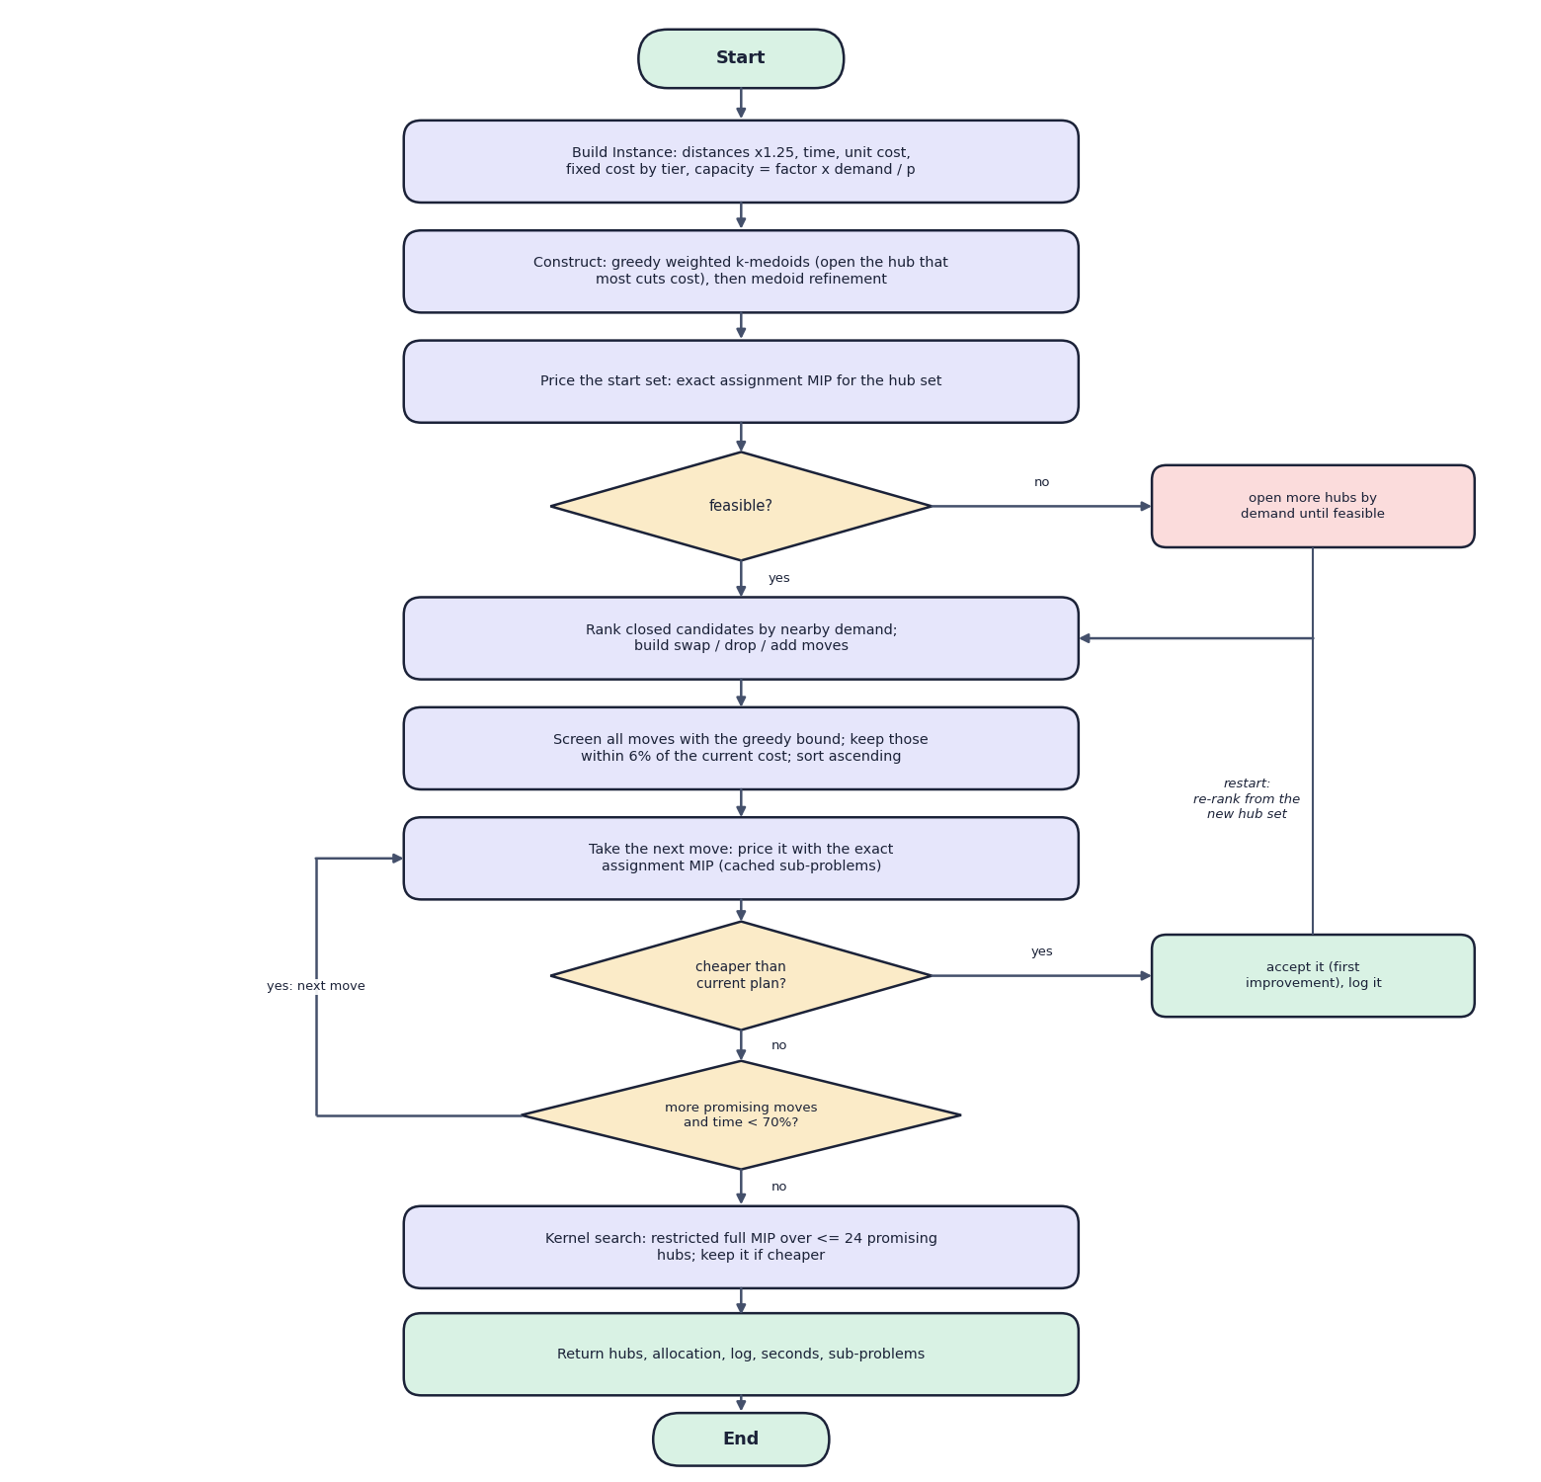
Fig. 10: Flowchart of the core algorithm: the matheuristic
The instance is built and a start set is constructed by a greedy weighted k-medoids rule followed by medoid refinement. It is priced by an exact assignment MIP; if it is infeasible, more hubs are opened by demand until it is feasible. The local search then ranks closed candidates, builds swap, drop and add moves, screens them with a greedy bound, and prices the best-screened move; a cheaper plan is accepted (first improvement) and the search restarts. When no promising move remains or 70% of the time is spent, the kernel search polishes the result and the best plan is returned.

